Friendstagram

CHANGE MANAGEMENT PLAN
Version <1.0>
<14/03/2022>

VERSION HISTORY
Revision Number | Date | Primary Author(s) | Comments
0.1 | March 13th, 2022 | Manav Arora, Jovan Huang Tian Chun, Clarence Hong Shi Man, Tan Hui Zhan | First version
0.2 | Mar 13th, 2022 | Manav Arora, Jovan Huang Tian Chun, Clarence Hong Shi Man, Tan Hui Zhan, Zhu Weiji, Royce Ang Jia Jie | Completed
1.0 | Mar 13th, 2022 | Manav Arora | Reviewed and approved

TABLE OF CONTENTS
1 INTRODUCTION 3
1.1 PURPOSE OF THE CHANGE MANAGEMENT PLAN 4
2 CHANGE MANAGEMENT PROCESS 4
2.1 CHANGE REQUEST PROCESS FLOW REQUIREMENTS 4
2.2 CHANGE REQUEST FORM AND CHANGE MANAGEMENT LOG 4
2.3 EVALUATING AND AUTHORIZING CHANGE REQUESTS 5
2.3.1 Change Control Board 6
3 RESPONSIBILITIES 6
Appendix A: Change Management Plan Approval 6
Appendix B: References 7
Appendix C: Key Terms 8
Appendix D: Change Request Form Example 9
Appendix E: Change Management Log Template 10

INTRODUCTION

PURPOSE OF THE CHANGE MANAGEMENT PLAN
The Change Management Plan documents and tracks the necessary information required to effectively manage project change from project inception to delivery.
The Change Management Plan is created during the Planning Phase of the project. Its intended audience is the project manager, project team, project sponsor and any senior leaders whose support is needed to carry out the plan.

CHANGE MANAGEMENT PROCESS
The Change Management process establishes an orderly and effective procedure for tracking the submission, coordination, review, evaluation, categorization, and approval for release of all changes to the project’s baselines.

CHANGE REQUEST PROCESS FLOW REQUIREMENTS
Step | Description
Generate CR | A submitter fills up a CR Form and submits the completed form to the Change Manager for validation and approval. Change requests could occur in any of the following:  - Prior error  - Client request  - User request  - Maintenance  The CR form outlines:  - Justification for change  - Description of change  - Risk and Cost analysis  - Priority order
Log CR Status | The Change Manager enters the CR into the CR Log. The CR’s status is updated throughout the CR process from initiation, analysed, approved (or rejected).
Evaluate CR | Project personnel review the CR and provide an estimated level of effort to process, and develop a proposed solution for the suggested change. Evaluation includes:  - Planning and risk mitigation  - Time allocation and scheduling  - Implementation and roll out  - alternative planning
Authorize CR | Approval to move forward with incorporating the suggested change into the project/product. Change Manager is responsible for authorization of CR forms. Approval is subject to the team’s evaluation and viability of change.
Implement CR | If approved, make the necessary adjustments to carry out the requested change and communicate CR status to the submitter and other stakeholders. This implementation is carried out by the release and development team. All the necessary development processes and testing need to be completed in order to implement any change.
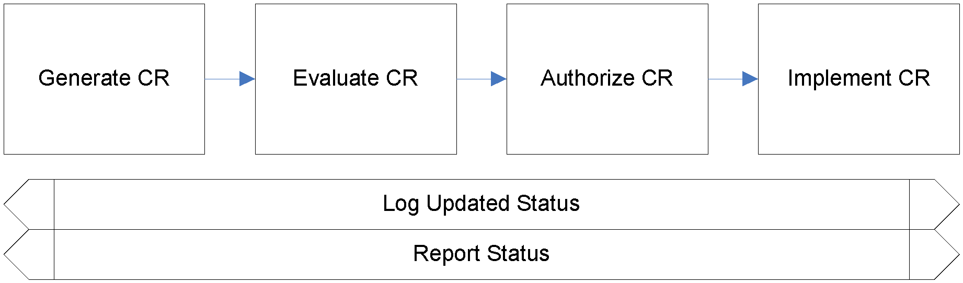

CHANGE REQUEST FORM AND CHANGE MANAGEMENT LOG
Element | Description
Date | The date the CR was created
CR# | Assigned by the Change Manager
Title | A brief description of the change request
Description | Description of the desired change, the impact, or benefits of a change should also be described
Submitter | Name of the person completing the CR Form and who can answer questions regarding the suggested change
Phone | Phone number of the submitter
E-Mail | Email of the submitter
Product | The product that the suggested change is for
Version | The product version that the suggested change is for
Priority | A code that provides a recommended categorization of the urgency of the requested change (High, Medium, Low)

EVALUATING AND AUTHORIZING CHANGE REQUESTS
Change requests are evaluated using the following priority criteria:
Priority | Description
High | Change requests in this level should be addressed immediately as negligence will lead to a crash in the application. High priority change requests are those that address bugs that cause system failures.
Medium | The change request requires review, analysis and implementation. There is a possibility that ignoring the change will have an impact on the system. Examples of a medium priority change request are changes that involve improving system performance.  Change requests in this level necessitates review, analysis and implementation. While not of the utmost importance, ignoring such requests may affect the system. These requests include an improvement in system performance or addition of functionalities that are not critical i.e. not part of the main purpose of the web application.
Low | Change requests in the level are not urgent and they are addressed only when time permits. These changes usually bring about a small improvement in user experience and have no real direct impact to the usability of the web application.

Change requests are evaluated and assigned one or more of the following change types:
Type | Description
Scope | Change affecting scope
Time | Change affecting time
Duration | Change affecting duration
Cost | Change affecting cost
Resources | Change affecting resources
Deliverables | Change affecting deliverables
Product | Change affecting product
Processes | Change affecting process
Quality | Change affecting quality

Change requests are evaluated and assigned one of the following status types:
Status | Description
Open | Entered/Open but not yet approved or assigned
Work in Progress | CR approved, assigned, and work is progressing
In Review | CR work is completed and in final review prior to testing
Testing | CR work has been reviewed and is being tested
Closed | CR work is complete, has passed all tests, and updates have been released.

Change Control Board

Role | Name | Contact | Description
Project Manager | Manav Arora | 91332470 | Ensure that the change request is valid and feasible before approving it for the project.
QA Manager/Engineer | Jovan Huang | 84828349 | To analyse if the change request will affect the quality of the system.
Release Manager/Engineer | Clarence Hong | 90345883 | Analyse and ensure that the changes are significant and suitable for a release.

RESPONSIBILITIES

Role | Name | Contact | Description
Project Manager | Manav Arora | 91332470 | Ensure that the change request is valid and feasible before approving it for the project.
QA Manager/Engineer | Jovan Huang | 84828349 | To analyse if the change request will affect the quality of the system.
Release Manager/Engineer | Clarence Huang | 90345883 | Analyse and ensure that the changes are significant and suitable for a release.
Lead Developer, Frontend Developer | Royce Ang | 90023456 | Overall incharge of the development process and responsible for the technical aspects of product release. The lead developer will be involved in all the change development processes.  Frontend developer who is in charge of handling the frontend server and React JavaScript web application. Frontend change requests approved by the Change Control Board (CCB) will be handled by the frontend developer as well as the lead developer.
Backend Developer | Zhu Weiji | 84848484 | Backend developer who is in charge of handling the backend server and database. Backend change requests approved by the Change Control Board (CCB) will be handled by the backend developer as well as the lead developer.
QA Engineer | Tan Hui Zhan | 93909090 | To analyse if the change request will affect the quality of the system.

Appendix A: Change Management Plan Approval
The undersigned acknowledge they have reviewed the Mr. Boba Change Management Plan and agree with the approach it presents. Changes to this Change Management Plan will be coordinated with and approved by the undersigned or their designated representatives.

Signature: | Manav Arora | Date: | 14/03/2022
Print Name: | Manav Arora
Title: | Project Manager
Role: | Project Manager

Signature: |  | Date:
Print Name:
Title:
Role:

Appendix B: References
The following table summarizes the documents referenced in this document.
Document Name and Version | Description | Location
Inspiration Change Management Plan, Version 1.0 | Inspiration - Change Management Plan | CZ3002 ASE Project Inspiration/Lab 4/D09_ChangeManagementPlan_V1.0.pdf

Appendix C: Key Terms
The following table provides definitions for terms relevant to this document.
Term | Definition
Change Control Board (CCB) | A group of stakeholders who assess the impact of changes and approve changes before it is implemented. They will also determine when the change will be released.

Appendix D: Change Request Form Example
The example Change Request From attached below can be used to submit changes during the life of the project.

SUBMITTER - GENERAL INFORMATION
CR#
Submitter Name
Brief Description of Request
Date Submitted
Date Required
Priority | ☐ Low | ☐ Medium | ☐ High | ☐ Mandatory
Reason for Change
Other Artifacts Impacted
Assumptions and Notes
Attachment or References | ☐ Yes |  | ☐ No
INITIAL ANALYSIS
Hour Impact
Duration Impact
Schedule Impact
Comments
Recommendations
CHANGE CONTROL BOARD - DECISION
Decision | ☐ Approved | ☐ Approved w/Conditions | ☐ Rejected | ☐ More Info
Decision Date
Decision Explanation
Conditions

Appendix E: Change Management Log Template
The detailed Change Management Log template attached below can be used to track and manage requested changes during the life of the project.

Change ID | Change Description | Requester | Date Requested | Decision | Date Decision | Comment

